Steps to use Vivado in UTD engnx server

In this tutorial, I will illustrate the basic steps to connect to engnx server using “no machine“ software and use Vivado 2018.1 remotely in the server. That engnx server runs on Linux OS. Following are the steps:

1. Connect to UTD VPN using Palo Alto Global Protect. The steps are shown in the following page:

<https://www.utdallas.edu/oit/helpdesk/kb/?id=9455c876273ab45a49d1c44c4593147a43c69bb010>

1. Once the VPN is setup download nomachine software from the following site:

Windows:

<https://www.nomachine.com/download/download&id=8>

Mac:

<https://www.nomachine.com/download/download&id=7>

1. Install nomachine in your system, which is standard installation doing next-> next
2. Once nomachine is installed it will create a short cut on desktop and open it. Click continue.

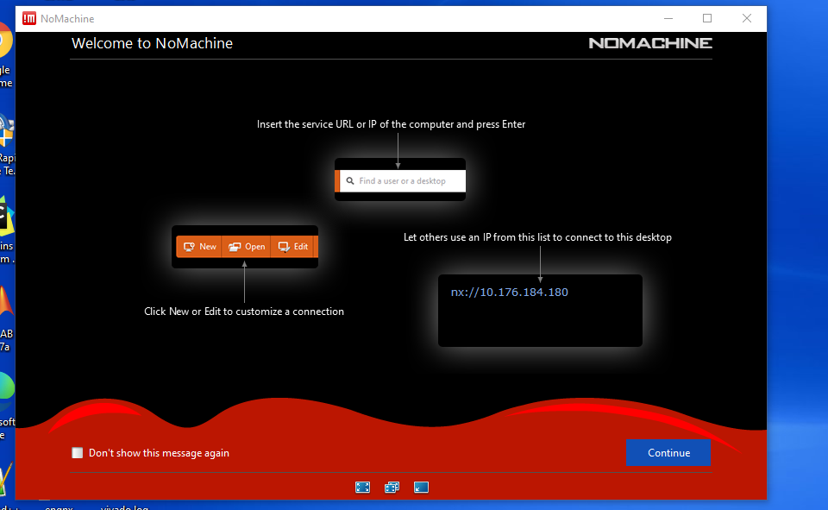

1. Click new in the next page

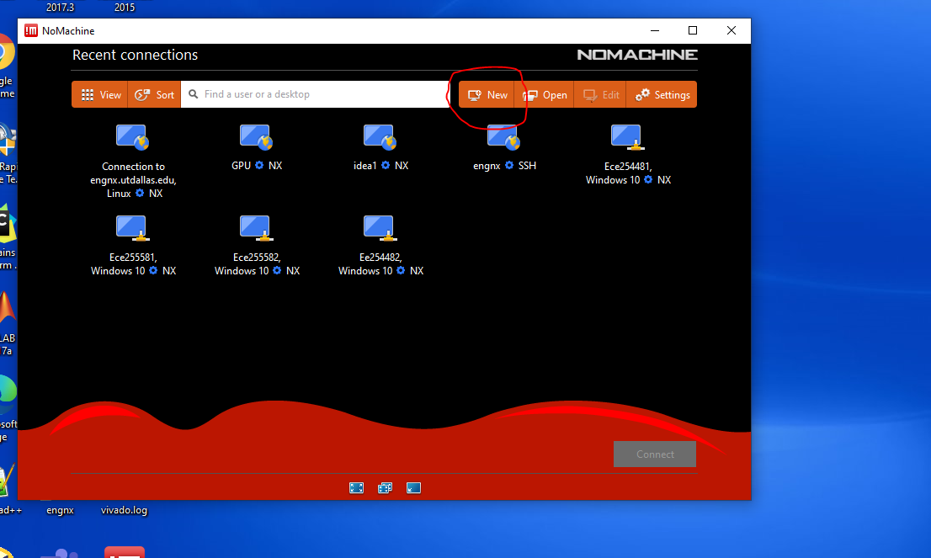

1. Select NX as protocol and click continue

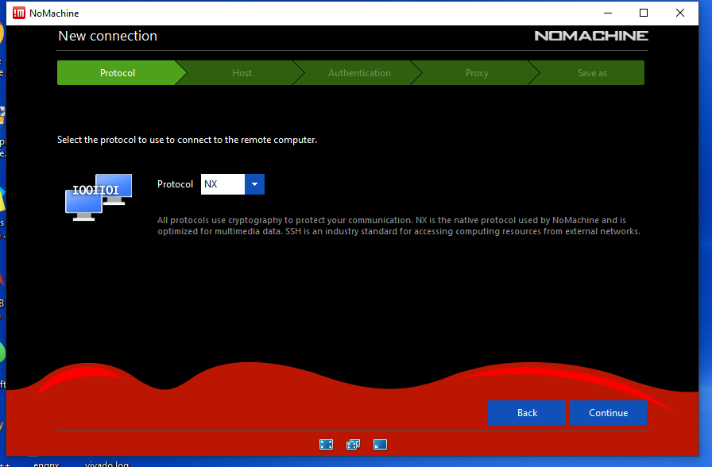

1. In the host field, give your [engnx.utdallas.edu](mailto:engnx.utdallas.edu) as Host.

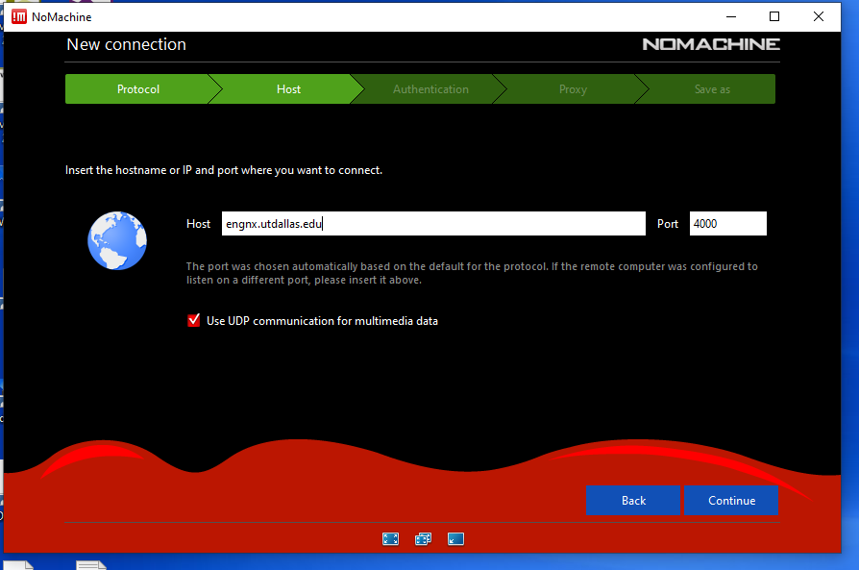

1. Select password in the next page

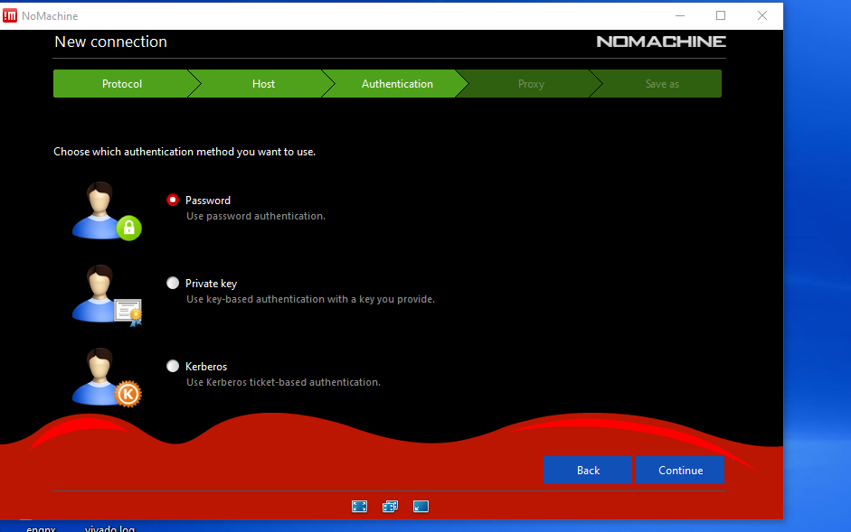

1. Click continue in the next page and done in the final page.

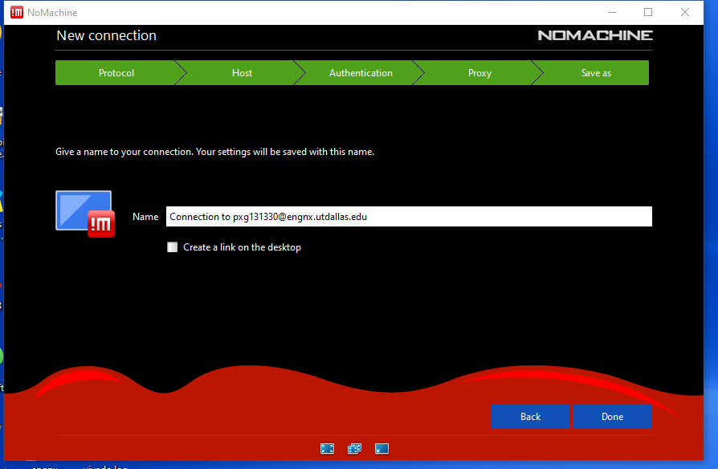

1. Your connection is setup now. You have to do till step 9 once only. In the next page select the icon saying “connection to engnx.utdallas....” and click connect.

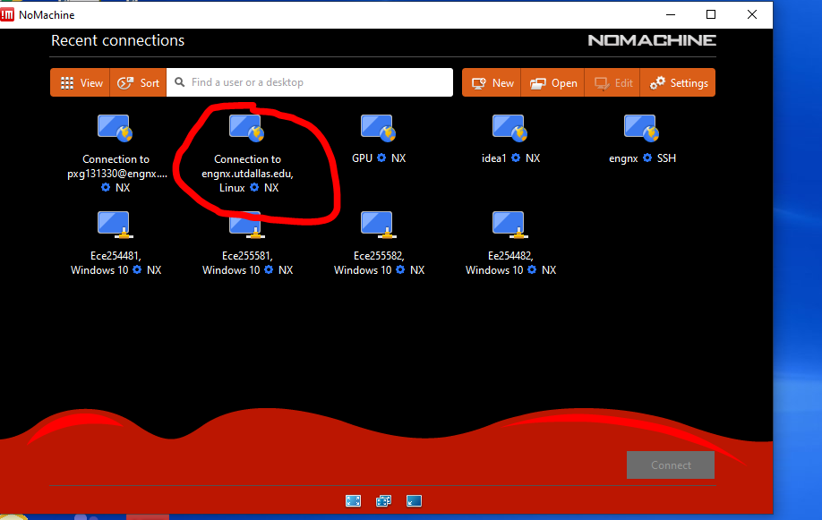

1. In the next window, select create “virtual desktop”
2. Click ok in the next 4 consecutive screens.
3. You should arrive at the following screen:

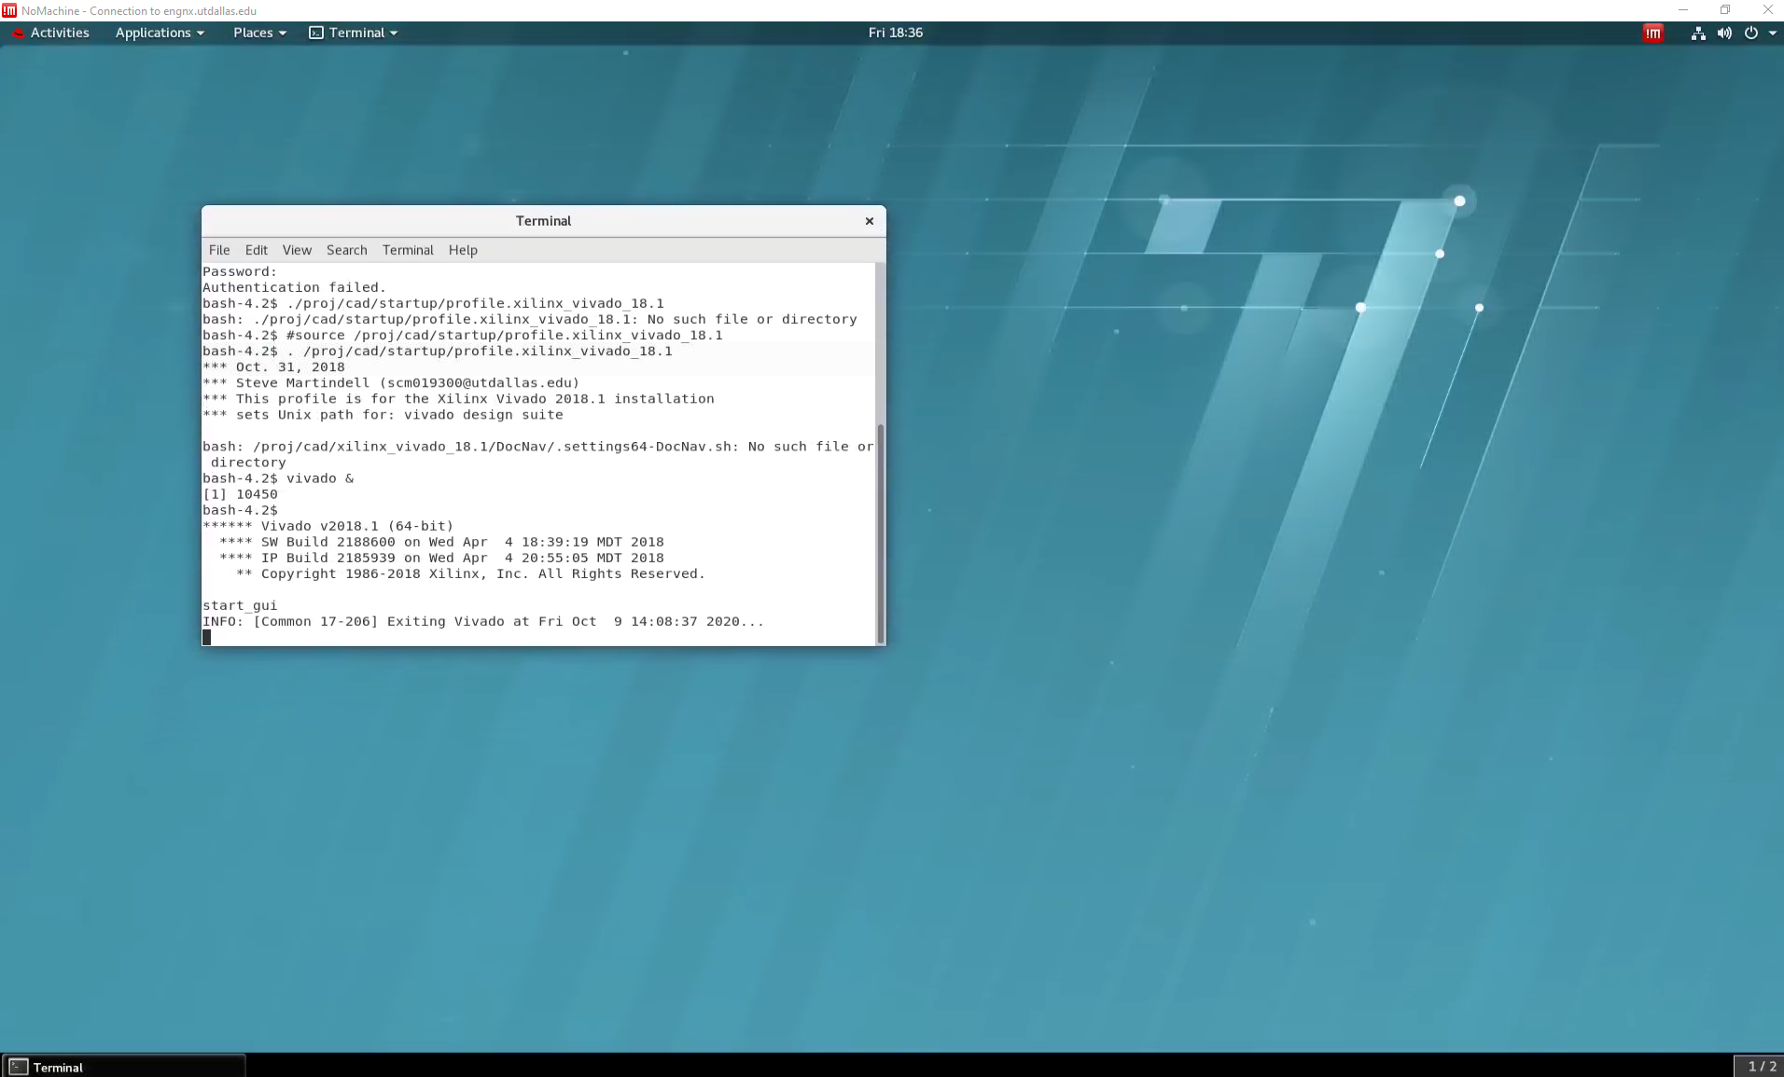

1. Go to “Applications” and open terminal.
2. In the terminal type the following:

. /proj/cad/startup/profile.xilinx_vivado_18.1

There is a space between the “.” and “/”.

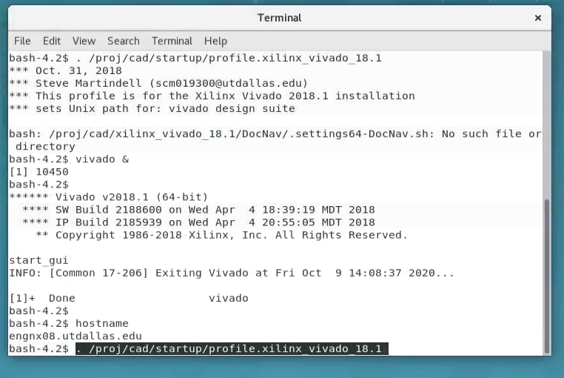

14. Next write “vivado &”, Vivado IDE should open.

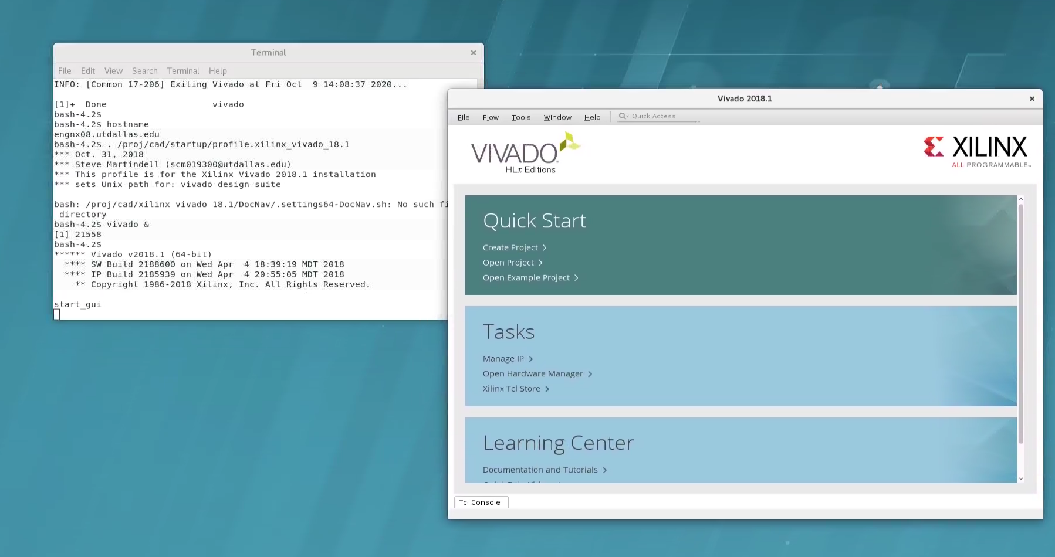

1. From here, you can follow the other manual sent by Dr. Bhatia.